Matthew Chang

CS2560 In-class Assignment

1. If-Else statement



1. Alternate if-else



1. Switch statement



1. Using global variables in a function.



1. Arrays and memory management

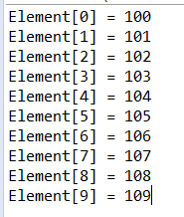

1. Using pointers to find addresses.

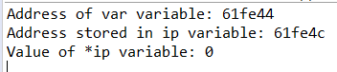

1. Using structs with pointers and functions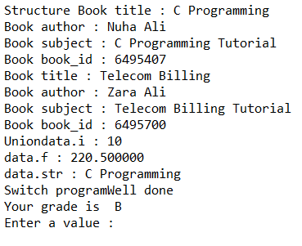
2. Unions



1. Accessing data in unions

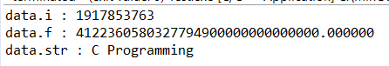

1. Another example of accessing unions.

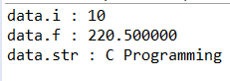

1. Swapping references.

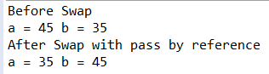

1. Read item as a character. Take user input.

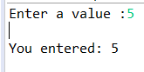

1. Read item as a string.

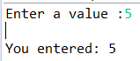

1. Open write only file. No output.
2. File printing

